Executive Steering Committee

Charter

**Revision History**

| **Version** | **Date** | **Revision Notes** |
| --- | --- | --- |
| 1.0 | 05/01/2022 | Accepted Version |
| 2.0 | 07/06/2023 | Updated Committee Requirements  Updated New Member Resources |
| 3.0 | 05/22/2024 | Updated Executive Steering Meetings |
| 4.0 | 10/XX/2024 | Updates to Governance Structure and Scope |

**Table of Contents**

Background 3

Committee Requirements 3

Governance Structure and Scope 3

Assumptions 4

Executive Steering Committee Meetings 5

ESC Membership and Organization 5

New Member Resources 7

# Background

The Chief Financial Officer (CFO) is identified as the Chief Fiscal Officer and designated agency head for the Department of Financial Services (DFS) by Article IV of the Florida Constitution and the functional owner of the Cash Management Subsystem (CMS). Section 215.94 of the Florida Statutes (F.S.) identifies DFS as the functional owner of the Florida Accounting Information Resource Subsystem (FLAIR). These systems support the business aspects of DFS Division of Accounting and Auditing (A&A), Division of Treasury (Treasury), and State agency financial accounting.

In accordance with Proviso of the 2014 General Appropriations Act (GAA), the Florida Planning, Accounting, and Ledger Management (PALM) Project was created to replace the existing FLAIR and CMS systems with a single, integrated financial management solution. The Florida PALM Executive Steering Committee (ESC) was formed in 2014, expanded to 15 members in 2015, and became law with the [2016 Implementing Bill](http://laws.flrules.org/2016/62). Adjustments to the structure and governance requirements are made annually as a new fiscal year Proviso and Implementing Bill become law, including the expansion to 17 members in 2022 and to 18 in 2024.

# Committee Requirements

Per GAA Implementing Bill, the ESC has the overall responsibility for ensuring the Project replaces FLAIR and CMS, meets its primary business objectives, and shall;

* Identify and recommend changes needed to implement the replacement subsystem that will standardize, to the fullest extent possible, the state's financial management business processes.
* Review and approve any changes to the project's scope, schedule and budget which do not conflict with the identified requirements.
* Ensure adequate resources are provided throughout all phases of the Project.
* Approve all major project deliverables and any cost changes to each deliverable over $250,000.
* Approve contract amendments and changes to all contract-related documents associated with the replacement of FLAIR and CMS.
* Review, and approve as warranted, the format of the bimonthly agency status reports to include meaningful information on each agency’s progress in planning for the Florida PALM Major Implementation, covering the agency’s people, processes, technology, and data transformation activities.
* Ensure compliance with ss. 216.181(16), 216.311, 216.313, 282.318(4)(h), and 287.058, Florida Statutes.

# Governance Structure and Scope

The Florida PALM Project Director and the ESC will make all significant Project decisions using the following multi-tiered governance structure:

**Tier 1: Florida PALM Project Director**

The Project Director is charged with managing the Project in conformance with the approved PMP and the Florida Information Technology Project Management and Oversight Standards, Chapter 60GG-1, Florida Administrative Code (F.A.C.). The Project Director is authorized to make Project decisions relevant to:

1. Scope - Changes that do not add or remove approved requirements, as identified in Attachment 5.1, or approved customizations, as identified in Attachment 5.2 of the SSI Contract, but that may:
   1. clarify the information contained in a requirement or customization description;
   2. update the “how met” for a requirement; or
   3. align requirements to approved customizations.
2. Schedule - Changes not associated with Major Project Deliverable due dates (as identified in Attachment 8 of the SSI Contract or the Project Schedule) or Stage Gates (as identified in Attachment 1 of the SSI Contract or the Project Schedule).
3. Cost - Changes within the budgeted spend plan categories, provided the changes do not result in an increase to the overall Project cost.

**Tier 2: Florida PALM ESC**

The following changes beyond the authority of the Project Director will be presented to the ESC for consideration:

1. Scope - Changes which impact Attachments 5.1 or 5.2 of the SSI Contract by:
   1. adding or removing approved Project requirements or customizations; or
   2. moving requirements to or from optional services.
2. Schedule - Changes impacting due dates of Major Project Deliverables or Stage Gates dates.
3. Cost - Changes which require:
   1. use of contingency funding;
   2. request of a funding change requiring Legislative Budget Committee (LBC) approval;
   3. a change in cost of a Deliverable that is above $250,000; or
   4. a change that causes a Deliverable’s cost to be greater than $250,000.

Beyond accountability to the scope, schedule, and cost of the Florida PALM Project, the ESC will help guide Project through milestones by evaluating progression points during the design, build, and testing activities listed on the Project Schedule. This includes evaluation of transitional readiness across people (agencies), business process, technology, and project management, as well as risks and issues determined by the Project and agencies.

Various resources are available to the ESC to help with decision-making. Such resources include the Florida PALM Advisory Council, a formal group representing 17 agencies, whose purpose is to assess impacts to the state financial business processes and agency staff, fact-finding, and information gathering and providing options, if applicable. Other resources include the DFS enterprise testimonies, Florida PALM Solution Center updates, agency testimonies and feedback, and the Florida PALM Oversight team.

# Assumptions

Certain assumptions are made for those undertaking the steering of the statewide implementation of a new financial management solution. If one of the below statements is invalidated, there is an assumption that there is insufficient knowledge on, or commitment for, the statewide implementation and membership may be reevaluated. The following assumptions should be made for members prior to joining the committee:

* There is commitment to the Project goals from all ESC members.
* There is consistent communication between an ESC member and their Agency Sponsor and/or Agency Liaison to be aware of agency status of transition, challenges, obstacles, and successes.
* Participate in discussion, be a voice for the State during ESC meetings, and share information after meetings among colleagues.
* There is an awareness of key Project resources such as Project Charter, business and technical requirements, Timeline, and Readiness Workbook.
* Understand the Project Schedule will be used to establish and monitor scope and progress of tasks supporting defined milestones and deliverables.
* Understand the Stage Gate decision milestones defined in the Project Schedule are opportunities for ESC to evaluate the progression of the Project.
* There will be sufficient engagement by ESC members and designated resources knowledgeable about their agency’s business processes.
* Partnerships established with external advisors will be collaborative to focus on the value to, and success of, the Project.

# Executive Steering Committee Meetings

Meetings are primarily scheduled on the fourth Wednesday of every month but may be rescheduled due to conflicts or holidays. Committee members should come to meetings prepared to engage with other committee members, be prepared for voting actions, and represent their agency in collaborative discussions. The following are also consistent of ESC meetings:

1. The CFO or the Executive Sponsor of the Project shall serve as chair of the ESC.
2. The ESC will meet at least monthly or as required, at the call of the Chair.
3. Meeting topics include matters related to the Project’s scope, schedule, budget, Project risks, Project issues, decisions made by the Project Director, and change requests, and other relevant implementation information. Updates on production support will also be shared, including known issues, fixes, enhancements, and Florida PALM Solution Center support to end users.
4. The meeting agenda, presentation, and supporting materials will be published on the Florida PALM website and shared prior to the meeting.
5. ESC actions shall be taken by a vote of at least eight affirmative votes with the CFO or the Executive Project Sponsor of the project voting on the prevailing side.
6. A quorum of the ESC consists of at least 10 members present in order to conduct a vote.
7. If requested by the Chair, members may electronically submit their vote in advance when there is an anticipated absence from a scheduled meeting during which a voting action is noticed. Electronic votes submitted in advance of a meeting do not change the quorum requirements for 10 attendees to be present.
8. Individual members may be allowed to attend a meeting virtually upon approval of the Chair. Members attending virtually may count towards the quorum requirement.
9. Meetings of the ESC may be conducted virtually in cases where an in-person meeting is not feasible.
10. All meetings will be publicly noticed.
11. No later than 14 days before a meeting of the ESC the chair shall request input from committee members on agenda items for the next scheduled meeting.
12. Meeting minutes and video recording will be published on the Florida PALM Website following the meeting.

# ESC Membership and Organization

Per GAA Implementing Bill, the ESC membership is as follow:

Table 1: ESC Membership

| **Role(s)** | **Agency** | **Appointed By** |
| --- | --- | --- |
| Chief Financial Officer or Executive Project Sponsor | DFS | Chief Financial Officer |
| Department of Financial Services Division of Treasury Representative | DFS | Chief Financial Officer |
| Department of Financial Services Chief Information Officer | DFS | GAA Implementing Bill |
| Two (2) Department of Financial Services Division of Accounting & Auditing Representatives | DFS | Chief Financial Officer |
| Executive Office of the Governor (LAS/PBS) Representative | EOG | Governor |
| Executive Office of the Governor (OPB) Representative | EOG | Governor |
| Department of Revenue Finance and Accounting Representative | DOR | DOR Executive Director |
| Department of Management Services (Human Resources) Representative | DMS | DMS Secretary |
| Department of Management Services (Purchasing) Representative | DMS | DMS Secretary |
| Department of Environmental Protection Chief Information Officer | DEP | GAA Implementing Bill |
| Department of Business and Professional Regulation Representative | DBPR | DBPR Secretary |
| Florida Fish and Wildlife Conservation Commission Representative | FWC | Chair of FWC |
| State Agency Administrative Services Director | DOT | Governor |
| Department of Education Budget Director | DOE | GAA Implementing Bill |
| Executive Sponsor of the Florida Health Care Connection (FX) System | AHCA | AHCA Secretary |
| Assistant Deputy Secretary for Finance | AHCA | GAA Implementing Bill |
| State Chief Information Officer | Florida Digital Service | GAA Implementing Bill |

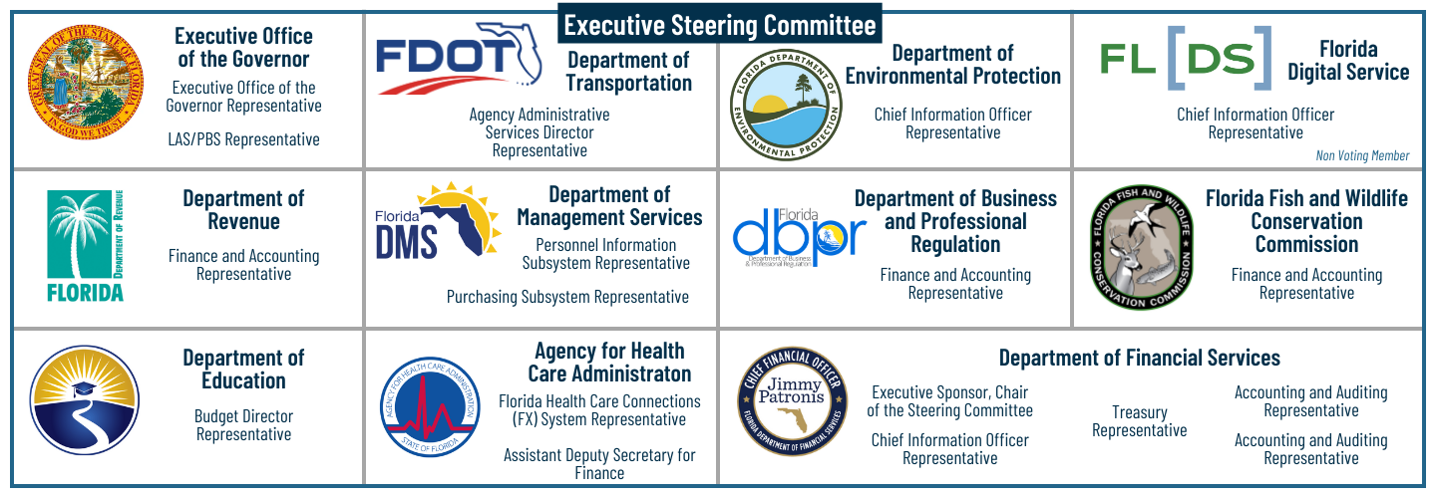

Figure 1: ESC Membership

The following represents the interaction between the ESC, the Project team, and external stakeholders. Business and Project Sponsors attend ESC meetings. An Advisory Council gives feedback and options to the ESC for decision-making. External stakeholders attend ESC meetings during applicable Project activities (i.e., production updates, enterprise activities, requirements/business process updates, testing activities) or upon request.

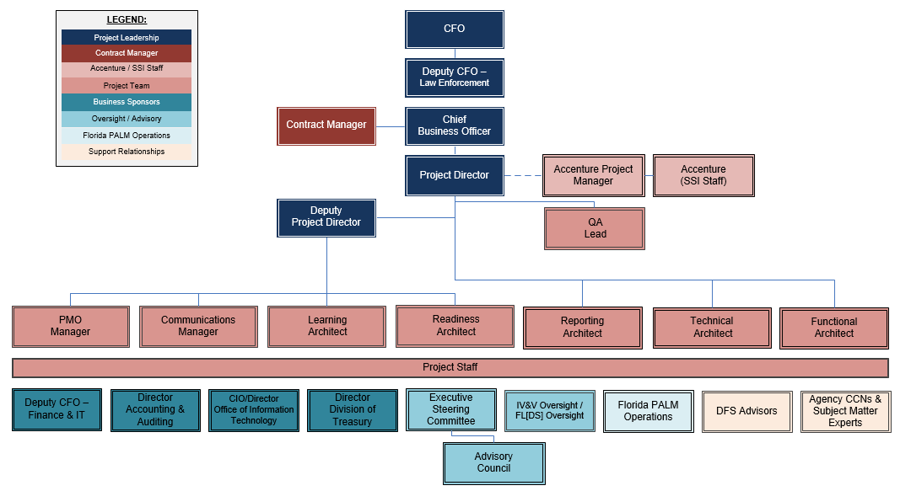

Figure 2: Florida PALM Organization and External Stakeholders

# New Member Resources

To help you familiarize yourself with the Florida PALM Project and the ESC, the following resource links will take you to various pages and documents that are located on the [Florida PALM website](https://myfloridacfo.com/floridapalm/).

* The [Project Charter](https://sf01.myfloridacfo.com/docs-sf/florida-palm-libraries/resources/project-management/florida-palm-project-charter-7d30836d1030140988481b465597fa3a1.pdf?sfvrsn=640976e8_8) details the implementation approach, Project organization, and critical success factors.
* ESC meeting announcements, materials, meeting minutes, and video recordings are located on the [ESC/Oversight](https://myfloridacfo.com/floridapalm/oversight) page. Outlook meeting invitations; however, will be sent through email for your calendar.
* A brief [Project Overview](https://sf01.myfloridacfo.com/docs-sf/florida-palm-libraries/governance/project-history.pdf?sfvrsn=ba627924_2) shares goals, partners, previous milestones, and a historical timeline.
* ESC meetings are publicly noticed meeting and must be conducted in accordance with the [Sunshine Law](http://www.myflsunshine.com/pages.nsf/Main/321B47083D80C4CD8525791B006A54E3#9).
* You can find various artifacts on the Florida PALM website under their appropriate categories, such as implementation approach documents, the Project timeline, the Business Case and FLAIR Study, a communications subscription, and podcast episodes.