Project Charter
For Florida PALM

Revision History

Version | Date | Revision Notes
1.0 | 11/11/2015 | Original document created with basis from content removed from Pre-Design, Development, and Implementation (Pre-DDI) Project Management Plan
2.0 | 01/14/2016 | Updated based on Chief Financial Officer review to align with FLAIR Study
3.0 | 02/09/2016 | Updated to incorporate proposed structure identified by PCB APC 16-02
3.1 | 02/18/2016 | Updated to incorporate “Appointed By” to Executive Steering Committee members
3.2 | 02/19/2016 | Updated to clarify authority of Project Director for cost variances
4.0 | 05/16/2017 | Accepted Version
4.1 | 05/24/2017 | Align Charter with PMP
4.2 | 03/26/2018 | Accepted Version
5.0 | 02/24/2020 | Accepted Version
5.1 | 02/02/2022 | Updated Contract Manager and Project Director roles and responsibilities, and Decision tier structure.
6.0 | 08/01/2022 | Updated background, Project goal #4, organizational structure, and roles and responsibilities
7.0 | 05/24/2023 | Updated to align with Amendment 8 and Proviso/Implementing Bill
8.0 | 08/23/2023 | Updated Florida Digital Service representative to be appointed by DMS Secretary
9.0 | 05/22/2024 | Added AHCA member per Implementing Bill  Added ESC voting options
10.0 | 10/30/2024 | Updated Appendix A – Project Governance
11.0 | 07/30/2025 | Updated the Roles and Responsibilities of the ESC and ESC Membership sections of Appendix A – Project Governance to align with the 2025 GAA and Implementing bills
12.0 | 08/##/2026 | Updated Roles and Responsibilities of the ESC to align with the 2026 Implementing Bill, and updated Project Org Chart to reflect new Project key roles

Table of Contents
Project Overview 4
Implementation Approach 8
Project Organization Structure 8
Assumptions 12
Critical Success Factors 12
Appendix A – Project Governance 14
Appendix B – Project Scope 17

Project Overview

Background
The Chief Financial Officer (CFO) is identified as the chief fiscal officer and designated agency head for the Department of Financial Services (Department or DFS) by Article IV, § 4(c), of the Florida Constitution (Fla. Const.) and Chapter 17, section 17.001 and Chapter 20, section 20.21(1), Florida Statutes (F.S.). Section 215.94, F.S., identifies DFS as the functional owner of the Florida Accounting Information Resource Subsystem (FLAIR) and the CFO as the functional owner of the Financial Management Subsystem (FMS). FLAIR and FMS perform various financial and cash management functions. The systems support the business aspects of the Department’s Division of Accounting and Auditing (A&A), Division of Treasury (Treasury), and state agency financial accounting.

A capable, flexible, and reliable financial management system is essential for an enterprise the size of Florida. FLAIR is not keeping up with the state’s evolving and growing business needs and, as time goes on, the operational risk of relying on FLAIR only increases. Additionally, FLAIR was built using a code base that is outdated, causing increasing difficulty in finding development staff that can support the environment. The limitations of FLAIR and the associated impacts (e.g., the proliferation of agency compensating systems and agency unique processes) are not trivial and negatively impact the operational productivity and the financial management of the state.

The ability of the CFO and DFS to perform their mission is becoming increasingly difficult given the significant limitations of FLAIR. A new financial management solution is needed and the need for change is supported by the following factors:

- Agencies have implemented and continue to implement workarounds and financial-related business systems to fill “gaps” created by FLAIR limitations. The proliferation of these agency-unique processes and compensating financial systems will only continue as business needs change. The result is an increase in operational complexity, maintenance, and administrative costs, and increased difficulty for the CFO and DFS to manage the state’s financial resources. A secondary impact related to the number of agency-unique processes and homegrown systems will be an increased level of complexity to transition to the new financial management solution.
- FLAIR was developed over 40 years ago and is maintained on an outdated code base and data structure and cannot be sufficiently updated to meet the state’s changing business and financial management needs. This is demonstrated by the complexity and limited ability to add data elements, change data elements, etc. The limiting factor is the structure of the programming modules’ code base.
- Resources needed to maintain FLAIR are scarce and are becoming more limited. The loss of irreplaceable institutional knowledge and lack of qualified resources to support FLAIR increases future operational risk when changes to the system are needed or system issues need to be resolved. Resource knowledge is critical since system documentation may not always reflect the full productive state.
- FLAIR and the Florida Financial Management Information System (FFMIS) subsystems are designed and operated in a way contrary to supporting an enterprise‐wide financial management solution. If the state wants to move toward an enterprise‐wide financial management solution, the state will need to establish a flexible foundation to allow for evolution (e.g., add capabilities) and to be a catalyst for future statewide operational efficiency and effectiveness efforts.

As part of the 2014 General Appropriations Act (GAA), DFS was directed to begin the process of replacing the existing FLAIR and Cash Management System (CMS) systems with a single, integrated financial management solution.

Document Purpose
The purpose of this document is to establish in writing, and gain agreement on, the Project’s vision, purpose, and expected value to the state. This document communicates the Project governance and organizational structures as well as Project Team role descriptions. Other important project management and governing functions such as decision authority, communication management, success criteria, and cost management are captured in other created and approved documents.

CFO Statutory Mission
The CFO has the legal responsibility for settling and approving accounts against the state and maintaining all state funds and securities. Chapter 17, F.S., and Article IV, § 4(c) Fla. Const. establish the CFO’s mission, role, and responsibilities. DFS exists to support the CFO in performing their role and responsibilities. As outlined in law, the CFO’s mission (mission) is critical to the State’s financial stability, and accordingly, all current and future Project activities should support this mission.

Project Vision and Goals
It is critical to have a Project vision that clearly articulates future objectives, is supported by the mission and is founded on guiding principles. The guiding principles must support the mission and take into account the current-state environment and what is required for the CFO and DFS to perform the mission. Three guiding principles aligned to the authority granted by statute were developed to create the Project vision.

Table 1: Guiding Principles and Supporting Statutes
Guiding Principles | Supporting Florida Statutes
Implement a statewide financial management solution to enforce process standardization, promote economies of scale, and enable comprehensive, accurate financial information to be produced. | Section 215.93(2): No functional owner nor any other agency shall have the authority to establish or maintain additional subsystems which duplicate any of the information subsystems of the FFMIS.  Section 216.102(2): Financial information must be contained within FLAIR.  Section 216.141(3): The CFO shall use FLAIR in the performance of and accounting for all of his or her constitutional and statutory duties and responsibilities
Implement an evolving solution able to respond to and support economic, political, and social changes in a timely manner. | Section 215.91(6): FFMIS subsystems shall be designed to incorporate the flexibility needed to respond to the dynamic demands of state government in a cost-conscious manner.  Section 215.93(1): FFMIS shall be fully implemented and shall be upgraded as necessary to ensure efficient operation of an integrated financial management information system and to provide necessary information for the effective operation of state government.
Implement a solution to support a true Statewide, unified information system. | Section 215.91(2): FFMIS shall be a unified information system.  Section 215.91(7): State agencies have access to and use FFMIS for the collection, processing, and reporting of financial management data required for efficient and effective operation.

The vision statement sets the future direction and is the basis for long-term planning. The following Project vision statement encapsulates the guiding principles:

Implement a statewide accounting system that enforces standardization, acts as a scalable foundation to evolve as business needs change, and positions Florida for future innovation as it considers a true enterprise-wide solution.

It is critical to have defined goals aligned to the vision that address the current FLAIR limitations, support the mission, and deliver business value. The goals for the Project are:

- Reduce the State’s risk exposure by harnessing modern financial management technology built on the premises of scalability, flexibility, and maintainability.
- Improve State and agency-specific decision-making by capturing a consistent and expandable set of data.
- Improve the State’s financial management capabilities to enable more accurate oversight of budget and cash demands today and in the future.
- Increase internal controls by enabling standardization and automation of business processes within and between DFS and agencies.

Figure 1 below provides a visual representation of the relationships between the Project’s mission, vision, guiding principles and goals and the associated statutory requirements.
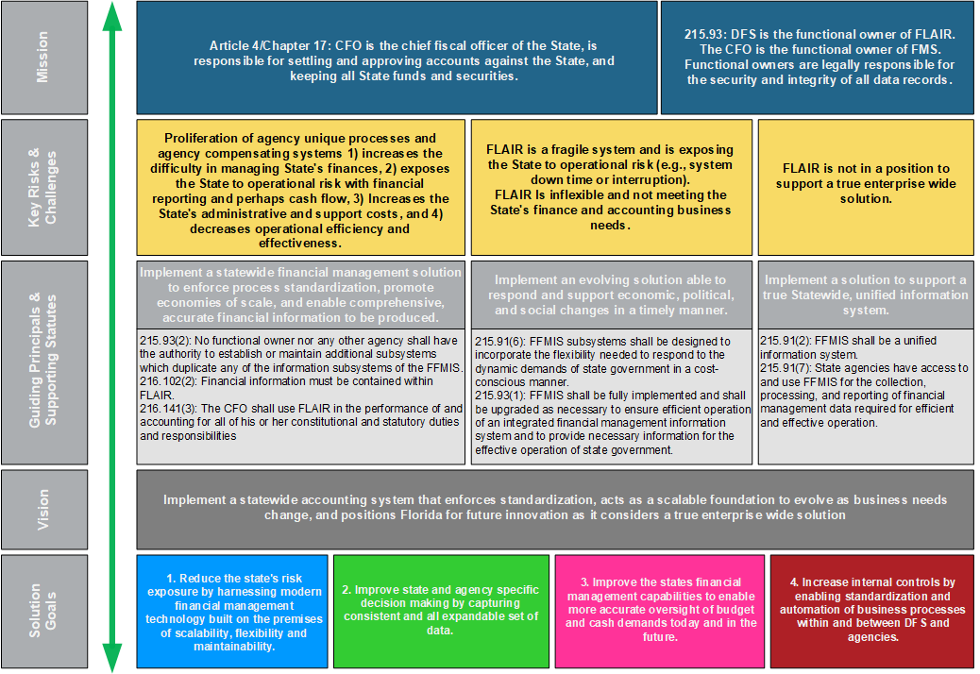
Figure 1: Relationship Between Mission and Project Vision

Implementation Approach
The multi-year Project will have several phases, or “major implementations”, made up of one or more “waves”:

- Pre-DDI – This initial phase (the Pre-Design, Development and Implementation or Pre-DDI phase) includes planning for DDI readiness, business process standardization, and procurement of the financial management solution.
- CMS Wave – Design, development, and implementation of treasury and cash management functionality.
- Financials and Payroll Waves – Design, development, and implementation of Financials, Payroll, and Data Warehouse / Business Intelligence functionality.

To achieve Project goals, Project activities will extend past technology related activities and will address the change of business processes and people side of change. During each implementation, the Project will be staffed to support four critical dimensions: people, process, project management, and technology. Post-implementation, the Project will coordinate production support responsibilities with other DFS operational staff.

The Department will maintain the Project Management Plan (PMP) via regular reviews. This may include a review and update in preparation for each major implementation. The PMP will outline the processes for managing Project components including communications, documents, schedule, action items, issues, decisions, lessons learned, and risks. The following sections describe the high-level Project scope, schedule, and organization, and the impacted stakeholders applicable to all waves of the Project.

Scope
The scope will be refined at the beginning of each wave of the Project. The detailed scope of Pre-DDI and high-level scope of subsequent waves can be found in Appendix B – Project Scope.

Schedule
A detailed Project Schedule, including milestones, will be developed for each major implementation of the Project.

Cost
The Project will work through the defined Florida Appropriations process to obtain the budget needed to support Project activities.

Project Organization Structure
This Project Charter includes the Project organization and a listing of roles and responsibilities. The decision-making authority is documented in Appendix A – Project Governance.

Project Team Organization
The Project Team will be comprised of state resources and contracted resources. Figure 2 depicts the Project’s organization, with the Project Team at the core supported by groups or positions in oversight, advisory, or support relationships.

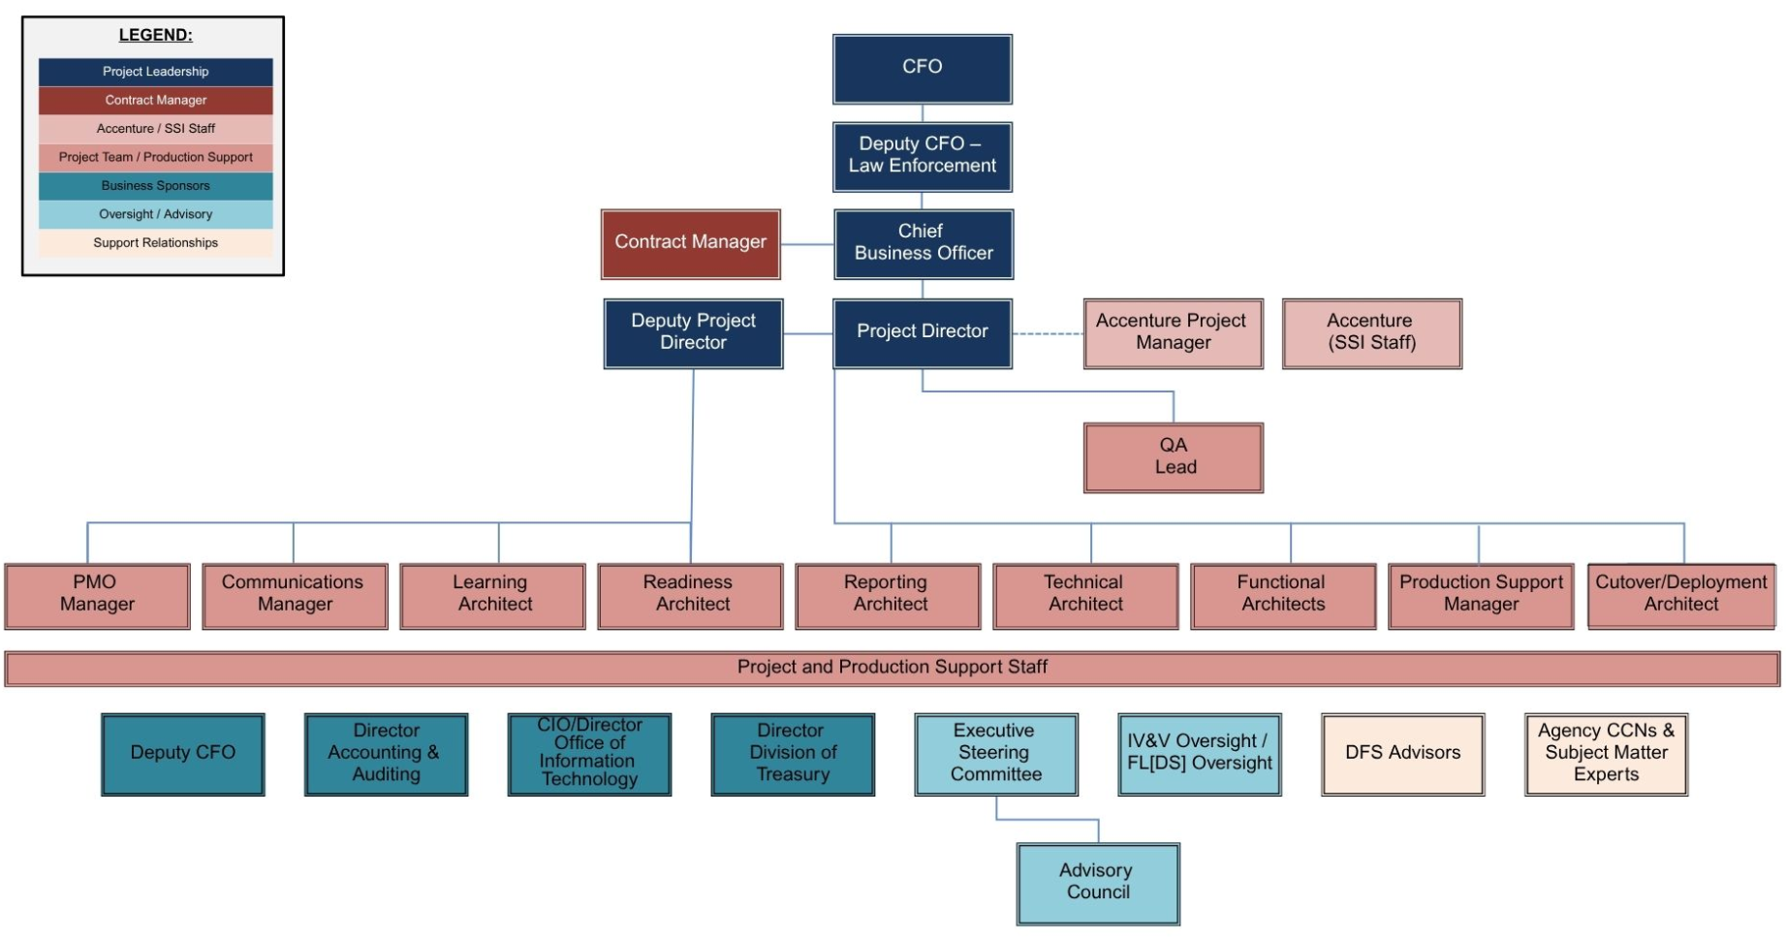

Figure 2: Project Organizational Chart

Project Roles
This section includes descriptions of the roles within the Project and that provide leadership, oversight, and support for the Project. The role of the Executive Steering Committee is further defined in Appendix A.

Project Leadership
- Chief Financial Officer – Provides support and guidance to the Executive Project Sponsor and communicates with the executive and legislative branch leadership or other stakeholders on Project-related topics.

- Deputy CFO – Law Enforcement – Serves as an escalation point for the Project’s Executive Sponsor in securing necessary resources and support for the Project’s objectives and ensures strategic alignment with Department objectives.

- Chief Business Officer – Serves as the Project’s Executive Sponsor and Chair of the ESC. Provides leadership and strategic direction and support to the Project Director and Deputy Project Director with regard to the execution of Project activities in support of its objectives.

- Project Director – Provides day-to-day Project leadership, ensuring the progress and successful completion of Project activities in accordance with the Project Schedule and the Project’s PMP. Provides strategic direction for the Project, gathering input from various stakeholders, informing impacted entities, including agencies, and maintaining a collaborative and effective relationship with the SSI Contractor. Approves or delegates approval for all Project artifacts, including deliverables and work products.

- Deputy Project Director – Serves as back up or delegate to the Project Director. Provides day-to-day leadership to the Communications, Project Management Office, Readiness, and Training Education and Development teams. Oversees the development and maintenance of Project operating processes, including the PMP.

Contract Manager – Serves as the contract manager for the Software and System Integrator (SSI) Contract. Responsible for reviewing and accepting or approving SSI Contract deliverables to ensure compliance with quality and contractual standards. Provides contract updates to the ESC and leads or coordinates amendments to the SSI Contract.

Accenture Project Manager – Leads the SSI Staff in performing the responsibilities necessary to fulfill the requirements of the SSI Contract. Works closely with the Project Director in providing daily leadership and provides regular updates to the ESC regarding Project progress.

Accenture Staff – Contractor staff assigned to lead or support implementation activities defined in the SSI Contract and the Project Schedule, and in accordance with the Project’s PMP.

QA Lead – Provides Quality Assurance Testing services for the Florida PALM Project. This ensures an application/software meets the State of Florida and Florida PALM Project’s defined standards and functionality (Requirements/Design/Build Specifications) prior to launch.

Project Management Office – Performs or leads project management and administrative activities for the Project. Prepares or updates Project guideline documents, such as the PMP or SOPs. Manages administrative functions, such as the Project’s budget, expenditures, procurements and human resource activities, and manages project management activities such as the Project Schedule and Change Requests, Risks, Action Items, Issues, Decisions, and Lessons Learned.

Communications Office – Performs or leads communication-related efforts for the Project. Manages the Project’s Style Guide, website, and Florida PALM inbox. Develops and distributes messaging and content. Coordinates and schedules critical stakeholder meetings, such as Advisory Council and ESC meetings.

Project Architects – Provides content and subject matter expertise regarding functional, learning, readiness, reporting, cutover & deployment, and technical. Works with state and contracted staff to develop and review assigned deliverables and work products.

Project Staff – Includes state and contractor support staff that perform administrative functions and implementation activities including design, build, test, and training activities defined in the Project Schedule, in accordance with the Project’s PMP. Guides and supports agency engagement and readiness activities.

Business Sponsors – Comprised of the Deputy Chief Financial Officer of Finance & IT and the Directors of the Division of Accounting & Auditing, Office of Information Technology/Chief Information Officer, and the Division of Treasury. These are the Department’s business-level leadership that provide strategic support to the Project team and that are responsible for the transformation of the Divisions and Offices that have direct ownership of accounting, technology, and cash management functions of the Department.

Executive Steering Committee – Comprised of members from selected agencies, per the GAA’s annual Implementing Bill and has the overall responsibility for ensuring that the Project meets its primary business objectives.

Advisory Council – Comprised of members from selected agencies that are impacted by the implementation of the financial management solution. This group facilities cross-agency discussion to provide options or recommendations on topics that influence current and proposed solution design and implementation.

Project Oversight – Comprised of Independent Verification & Validation (IV&V) and Florida Digital Services (FL[DS]). IV&V provides an objective assessment, as an independent third-party, of products and processes throughout the Project’s lifecycle. In accordance with Chapter 60GG-1, F.A.C., FL[DS] provides oversight and assures the Project meets all statutory requirements for information technology projects of this size.

Florida PALM Operations – Staffs and leads the Florida PALM Solution Center. Provides end user support and coordinates support for application and infrastructure support requests and system updates. Works with Project and Department staff and external stakeholders to review, develop and implement system enhancements.

DFS Advisors – Comprised of individuals or sections within the Department that provide subject matter expertise on topics such as budget, procurement and contracting, legal, and human resources.

Agency CCN & Subject Matter Experts – Includes agency state and contractor staff assigned specific roles to support the transformation and readiness activities of the agency. Agency CCN membership includes key roles, assigned by agency leadership such as Agency Sponsor and Agency Liaison.

Assumptions
Certain assumptions need to be made to identify and estimate the required tasks and timing for the Project. If one of the below statements is invalidated, there is an assumption that activities and estimates previously established for the Project will need to be re-evaluated for impacts to scope, schedule, and/or costs and adjusted accordingly.

- There is a commitment to the Project goals from all stakeholders
- The Project budget will be approved each fiscal year of the Project
- The Project Schedule will be used to establish and monitor the nature and progress of tasks supporting defined milestones and deliverables
- Revisions to the Project Schedule will follow the established PMP change management process
- The ESC will provide timely decisions on items impacting project scope and schedule
- All core functionality to be included in the financial management solution will be identified as part of the requirements gathering and finalized in the Requirements Traceability Matrix
- Changes resulting from significant Legislative, business requirement, or policy changes during the Project that materially impact the Project will follow the change management process as defined in the PMP
- Software customization will be evaluated on a case-by-case bases to determine if they can and should be implemented
- The current FLAIR system will function until the financial management solution, replacing FLAIR functionality, is implemented in production
- There is a sufficient talent pool within the budget from which to hire state staff resources
- SSI contractor and state resources will be available to support the Project Schedule
- There will be sufficient engagement by agencies by resources knowledgeable about agency business processes and technical capabilities
- There will be sufficient and adequate responses from the vendor community for contracted services
- Collaborative partnerships with external advisors will focus on value to and success of the Project
- Agencies will understand and document their internal processes and modify them where possible to accommodate the financial management solution functionality
- Agencies will understand and document their current state technical architecture and business systems and modify to integrate with the financial management solution
- Agencies will request and timely receive budget needed to prepare and modify current business systems to integrate

Critical Success Factors
With a project of this scale, there are critical success factors to monitor closely and adhere to throughout the Project. Consideration has been given to the lessons learned from Project Aspire. Ten key factors are identified to support the successful replacement of FLAIR and CMS with a financial management solution:

- Establish a comprehensive multi‐tiered governance model
- Confirm Project funding source
- Define the vision for standard business processes
- Manage system customizations
- Deploy a scope of functionality that will replace all of the functions performed by FLAIR, including Central, Departmental, Payroll, and Information Warehouse
- Utilize a controlled “build on success” approach to validate the financial management solution
- Leverage a waved rollout
- Foster a dynamic, inclusive culture that inspires teamwork, collaboration, and open communication
- Make timely decisions
- Focus and prioritize time and resources on items having the greatest impact on the success of Florida PALM

Appendix A – Project Governance

Governance Tiers
The Florida PALM Project Director and the ESC will make all significant Project decisions using the following multi-tiered governance structure:
- Tier 1: Florida PALM Project Director
The Project Director is charged with managing the Project in accordance with the approved PMP and the Florida Information Technology Project Management and Oversight Standards, Chapter 60GG-1, Florida Administrative Code (F.A.C.). The Project Director is authorized to make Project decisions relevant to:

  - Scope - Changes that do not add or remove approved requirements, as identified in Attachment 5.1, or approved customizations, as identified in Attachment 5.2 of the SSI Contract, but that may:
    - clarify the information contained in a requirement or customization description;
    - update the “how met” for a requirement; or
    - align requirements to approved customizations.
  - Schedule - Changes not associated with Major Project Deliverable due dates (as identified in Attachment 8 of the SSI Contract or the Project Schedule) or Stage Gates (as identified in Attachment 1 of the SSI Contract or the Project Schedule).
  - Cost - Changes within the budgeted spend plan categories, provided the changes do not result in an increase to the overall Project cost.

- Tier 2: Florida PALM ESC
The following changes beyond the authority of the Project Director will be presented to the ESC for consideration:

  - Scope - Changes which impact Attachments 5.1 or 5.2 of the SSI Contract by:
    - adding or removing approved Project requirements or customizations; or
    - moving requirements to or from optional services.
  - Schedule - Changes impacting due dates of Major Project Deliverables or Stage Gates dates.
  - Cost - Changes which require:
    - use of contingency funding;
    - request of a funding change requiring Legislative Budget Committee (LBC) approval;
    - a change in cost of a Deliverable that is above $250,000; or
    - a change that causes a Deliverable’s cost to be greater than $250,000.

Roles and Responsibilities of the ESC
The ESC has the overall responsibility for ensuring that the Project meets its primary business objectives. The ESC shall:

- Identify and recommend to the Executive Office of the Governor (EOG), the President of the Senate, and the Speaker of the House of Representatives any statutory changes needed to implement the financial management solution that will standardize, to the fullest extent possible, the State’s financial management business processes.
- Review and approve any changes to the Project’s scope, schedule and budget beyond the Project Director’s authority.
- Ensure that adequate resources are provided throughout all phases of the Project.
- Approve all Major Project Deliverables and cost changes to each Deliverable over $250,000.
- Approve contract amendments and changes to contract-related documents for the SSI Contract.
- Review, and approve as warranted, the format of the monthly agency status reports to include objective and quantifiable information on each agency’s progress in planning for the Florida PALM Major Implementation, covering the agency’s people, processes, technology, and data transformation activities.
- Ensure compliance with ss. 216.181(16), 216.311, 216.313, 282.318(4)(h), and 287.058, Florida Statutes.

The Chair of the ESC will establish and maintain a working group consisting of FLAIR users, state agency technical staff who maintain applications that integrate with FLAIR, and no less than four state agency finance and accounting or budget directors. The group, known as the Advisory Council, will meet monthly, with input provided by the members on agenda items, to review Florida PALM functionality, assess project impacts to state financial business processes and agency staff, and develop recommendations to the ESC for improvements. The group will be supported by the Florida PALM Project team, e.g., through system demos and project documentation, to fulfill its duties.

The ESC will monitor progress of agency readiness through review of periodic status reports submitted by agencies to the ESC. The form and format, approved by the ESC, will include meaningful information on each agency’s progress in planning for implementation across the agency’s critical operational elements of people, processes, technology, and data transformation activities.

The ESC and the Project Director will collectively serve as the Continuing Oversight Team for the SSI Contract, as described in Section 287.057(26), F.S., and will follow the requirements of that Section for agreements of $20 million or greater.

ESC Membership
The CFO or Executive Project Sponsor serves as the Chair of the ESC. The ESC will also be composed of the stakeholder members identified in Table 2.

Table 2: ESC Membership
Role(s) | Agency | Appointed By
Chief Financial Officer or Executive Project Sponsor | DFS | Chief Financial Officer
Department of Financial Services Division of Treasury Representative | DFS | Chief Financial Officer
Department of Financial Services Chief Information Officer | DFS | GAA Implementing Bill
Two (2) Department of Financial Services Division of Accounting & Auditing Representatives | DFS | Chief Financial Officer
Executive Office of the Governor (LAS/PBS) Representative | EOG | Governor
Executive Office of the Governor (OPB) Representative | EOG | Governor
Department of Revenue Finance and Accounting Representative | DOR | DOR Executive Director
Department of Management Services (Human Resources) Representative | DMS | DMS Secretary
Department of Management Services (Purchasing) Representative | DMS | DMS Secretary
Department of Environmental Protection Chief Information Officer | DEP | GAA Implementing Bill
Department of Business and Professional Regulation Representative | DBPR | DBPR Secretary
Florida Fish and Wildlife Conservation Commission Representative | FWC | Chair of FWC
State Agency Administrative Services Director | DOT | Governor
Department of Education Budget Director | DOE | GAA Implementing Bill
Executive Sponsor of the Florida Health Care Connection (FX) System | AHCA | AHCA Secretary
State Chief Information Officer | Florida Digital Service | GAA Implementing Bill

Executive Steering Committee Meetings
The ESC will meet monthly or as required, at the call of the Chair. Input on agenda items will be requested and the meetings will be scheduled at least two weeks in advance with ESC members and publicly noticed at least one week prior to the meeting date with a proposed meeting agenda. The Project Director or designated Project team member will prepare and distribute the final agenda, status reports, a list of deliverables for review (if needed), and other supporting documentation as appropriate prior to each meeting.

The CFO or Executive Project Sponsor chairs the ESC. A quorum of the ESC consists of at least 10 members present. Any ESC action shall be taken by a vote of at least eight members voting in the affirmative, with the CFO or the Executive Project Sponsor voting on the prevailing side. If requested by the Chair, members may electronically submit their vote in advance of a meeting when there is an anticipated absence from a scheduled meeting during which a voting action is noticed. Electronic votes submitted in advance of a meeting do not change the quorum requirements for 10 attendees to be present. Individual members may be allowed to attend a meeting virtually upon approval of the Chair. Members attending virtually may count towards the quorum requirement. Meetings of the ESC may be conducted virtually in cases where an in-person meeting is not feasible. The Project Director will update the ESC on matters related to the Project’s scope, schedule, budget, current issues and risks, recent decisions made by the Project Director, current and recent change requests, resources, and other relevant Project information. In addition, the contractor will provide an update on the Project progress.

Appendix B – Project Scope

Purpose
Scope is defined as the work that needs to be accomplished within available resources and time constraints to support successful Project implementation. Work to be accomplished includes products, services, or outcomes that meet the communicated critical success factors of the Project.

The following have been identified for the Project scope.

- Complete Project start-up: The Project will acquire the appropriate resources to execute strategies for fulfilling the Project’s critical success factors and delivering the scope. The Project is expected to develop, operationalize, and perform activities to secure facilities, people, processes, and technologies.
- Fulfill the procurement life cycle: The Project will develop and release a procurement for SSI services, evaluate responses, and negotiate the contract(s).
- Fulfill Project readiness for transition to the Implementation Phase: The Project will identify and fulfill Pre-DDI readiness outcomes. These outcomes include lessons learned from past and similarly sized projects; Project oversight rules; and the takeaways from the FLAIR Study.
- Execute the implementation of the financial management solution: The Project will implement a statewide financial management solution that enforces standardization, acts as a scalable foundation to evolve as a business needs change, and positions Florida for future innovation as it considers true enterprise-wide system. The scope and performance measures will be defined in the executed contract(s) and amendments.

Outcomes
The Project’s critical success factors outlined in this document were used to develop the outcomes listed below.

Project start-up
The following outcomes are important to fulfill the scope:

  - Acquire state staff
  - Acquire support staff (contracted services)
  - Accept Project Charter
  - Accept the PMP
  - Establish Project branding
  - Accept strategies
  - Acquire facilities and technology

Fulfill the Procurement Life Cycle
These outcomes are based on the State’s and Department’s procurement process:

  - Develop and implement a procurement strategy
  - Develop a procurement package
  - Evaluate replies
  - Obtain funding
  - Define financial management solution acceptance criteria
  - Determine best value and award contract(s)

Fulfill Project Readiness for Transition to the Implementation Phase
Operational readiness focuses on preparing people, processes, project management and product requirements for implementation. The outcomes for these four dimensions are:

- Project Management Process and Technology Readiness
  - Accept Project Governance (Appendix A to the Project Charter)
  - Establish multi-tiered governance structure
  - Manage support staff acquired through contracted services
  - Operationalize the PMP
  - Accept Project support tools’ vision and scope statement
  - Procure, install, and operationalize appropriate technologies to enable project management processes
  - Identify and acquire state resources needed for implementation
- People Readiness
  - Operationalize change management strategy
  - Establish a Communication Plan
  - Conduct and/or support collaboration activities
  - Develop stakeholder analysis
  - Prepare for workforce transformation
  - Initiate training and knowledge transfer approach
- Process and Product Requirements Readiness
  - Operationalize business process standardization strategy
  - Accept standardized business process models and business requirements
  - Identify and document policy considerations
  - Accept Business Requirements Management Plan
  - Operationalize Requirements Management Plan
  - Operationalize systems and data strategy
  - Accept Data Management Plan
  - Develop and Operationalize Pre-DDI Enterprise Architecture (EA) Strategy

Execute the implementation of the financial management solution
The Project will accomplish the following by executing implementation contract(s):

- Request approval for funding per the Legislative Budget Request (LBR) process
- Implement the financial management solution to accomplish Project goals

Out of Scope
The following areas are considered out of scope for the Project:
- Any functionality that duplicates functionality of the other Florida Financial Management Information System (FFMIS) subsystems with the intent of replacing the other subsystem. This includes:
  - Replacement of the Legislative Appropriation System/Planning and Budgeting Subsystem (LAS/PBS)
  - Replacement of the Personnel Information System (People First)
  - Replacement of the Purchasing Subsystem (MyFloridaMarketPlace)
- Agency business processes related to any of the functions included in the Personnel Information System, the Purchasing Subsystem or LAS/PBS
- Outsourcing operations of the current FLAIR and CMS systems.

Executive Steering Committee Approval
The signature below indicates approval of this document.

_________________________________________________________________________
Steven Fielder, Chair Date

