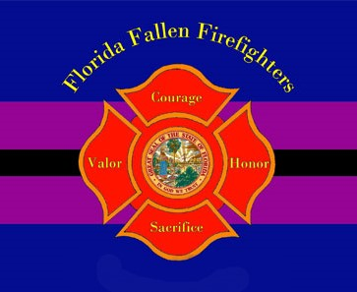
APPLICATION FOR INCLUSION-CANCER
Florida Fallen Firefighter Memorial

Submitted and attested to the best of your knowledge by:
Name and Rank: Click or tap here to enter text. (If other than Chief) Fire Chief: Click or tap here to enter text.
Department: Click or tap here to enter text.
Email: Click or tap here to enter text.
Phone: Click or tap here to enter text.

Firefighter Info: Full Name: Click or tap here to enter text.
Department: Click or tap here to enter text.
Rank: Click or tap here to enter text.
Dates of Employment Click or tap here to enter text.
Cancer Type: Choose an item.
Date of Death: Click or tap here to enter text.
Age: Click or tap here to enter text.
Did the firefighter work a minimum of five years? Yes ☐ No ☐
Were there any (s. 112.1816, F.S.) Line of Duty Death Benefits issued? Yes ☐ No ☐
(Career Firefighter Only)
Please check that you have attached the following:
☐ Death Certificate
☐ Cancer diagnosis documentation
☐ Completed Employer HIPPA form
☐ Post retirement fire service employment, if checked, please provide documentation

Family Contact Information: (for invitation and informational purposes only)
Name: Click or tap here to enter text. Relationship to Firefighter: Click or tap here to enter text.
Address: Click or tap here to enter text. City, State, Zip: Click or tap here to enter text.
(Additional family member information may be attached.)

Reviewed by: Fire Chief Signature (Print) Fire Chief Name Date

Please send all forms and documentation to: LODDApplication@MyFloridaCFO.com

