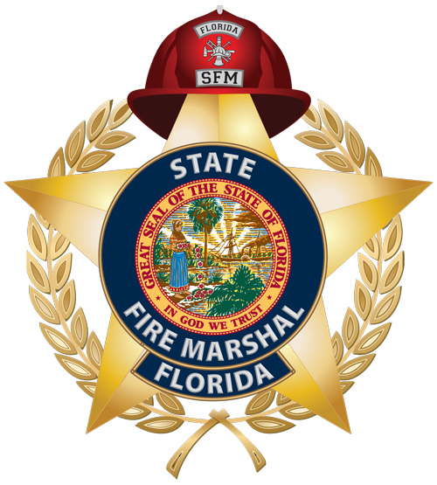
MODEL SAFETY COMMITTEE INJURY/ILLNESS INVESTIGATIONS FOR THE FIRE SERVICE
How to use this program

The purpose of this program is to provide a model for safety committees /safety coordinators (career and volunteer) to use when conducting investigations.

1. Modify this program to make it employer specific and meet your needs.

2. If you have an existing program, match it to this program and excerpt whatever is needed to make yours complete, if necessary.

3. If part(s) of the program do not apply because you do not have the equipment or conduct the operations referenced, delete it.

4. Should changes in statute, rule or adopted OSHA regulations impact this program, occur, it will be modified accordingly.

5. As you review, adopt or modify this program for your needs, we encourage and invite you to contribute to this program. With your input, this program will become a living document that evolves in the best interests of safety.

Model Safety Committee Injury Illness Investigations

Purpose
In accordance with Florida Statute 633.522(3)(c)2, The safety committee or safety coordinator is to investigate all workplace accidents, safety-related incidents, illnesses, and deaths. For the purposes of this document, the term incident is used for both an "accident" and "incident".

Scope
The safety committee function is to identify causation and future preventative measures in terms of procedures, equipment, training, or culture. Assignment of blame or disciplinary action is outside the scope of the committee’s responsibilities and the committee should not investigate until such issues are resolved through normal department channels.

Training
It is imperative for success of this component of the safety committee’s responsibilities that committee members and department personnel receive the necessary training to fully understand the contents of this document.

Why investigate incidents, illnesses and LODDs:
- To identify root causes and methods of future prevention.
- To determine compliance with existing safety procedures / protocol.
- To meet Florida statutory requirements.
- *The Safety Section of the Bureau of Fire Standards and Training (BFST) is tasked with conducting its own investigation regarding severe injury (i.e. Fatality; Loss of a limb, Loss or impairment of a bodily member, organ or mental faculty, More than 24 hours of hospitalization; or Permanent disfigurement to a commonly visible portion of the body) and injuries resulting from equipment failures.
- BFST will attempt, and prefers, to conduct a joint investigation with an active investigative arm of the safety committee.

What should be investigated?
The same principles that apply to a severe injury should apply to minor injuries and near misses. If causation can be identified at the minor incident level, preventative measures might well prevent or avoid a severe incident in the future. BFST identifies less than severe investigations as inquiries and defines them as an informal process used to identify cause and discover injury trends.

Investigative team equipment and tools

Equipment - Team member’s on-scene should be in PPE appropriate to the conditions.
Tools - Several “Go bags” should be available with clip boards, written witness statement forms that have specific language identifying why the statement is being requested and what they will be used for, pens, a camera, digital audio recorder, flash light, gloves and tape measure or a laser distance measuring device. While it is good to be prepared with this equipment, pre-arranging with law enforcement officials (LEO) for them to accomplish the scene investigation is even better as it leaves the team to focus on witnesses, equipment and conditions.

Conducting the investigation
The investigation is the responsibility of the safety committee / safety coordinator. The composition and assignment of the investigative team is also the responsibility of the committee / coordinator with administrative approval for budgetary impact. As a rule, more than five members become cumbersome. With regard to inquiries, one member is sufficient. The most difficult challenge for the investigator(s) is approaching without pre-judgment and bias which can cloud findings or cause true root causes to be overlooked or ignored.

Root Causes
Can be categorized as:
- Environment
- Assignment
- Culture
- Education / training
- Supervision
- Equipment
- Procedure / protocol
- Human error

Investigation Procedures
These procedures can be augmented to the level of the “IAFF Line of Duty Death or Injury Investigation Manual” which is available for download at http://www.iaff.org/hs/LODD_Manual/LODD%20or%20Injury%20Investigation%20Manual.pdf or reduced as the severity and circumstances of the case indicate. The basics of a standard incident investigation are as follows:

A. Incident Commander or Safety Officer on-scene as protocol dictates

- Secure the scene, call LEO to secure all equipment (gear, equipment, radios, etc) and establish a chain of custody.
- If the criterion of BFST is met (see * above), contact BFST at 352-369-2836.
- Notify Administration as protocol directs.
- Obtain written witness statements from all on scene describing where they were, what they were doing and what they saw or heard. Conjecture or second hand information is not needed or desired.

B. Administration

- Contact designated member(s) of the safety committee.
- Request scene investigation from LEO if previously arranged.
- Collect written witness statements. These will be used for documentation and to select those to be interviewed.

C. Investigative team

- Accumulate all information regarding the incident including but not limited to:
- FD information - Run report, 1st report of injury, written witness statements, repair / maintenance records.
- LEO - Scene photos, police report, scene investigation.
- Non-traditional sources- Consider street, private or security cams as well as civilian media taken during the event.
- Conduct recorded interviews of the selected individuals making sure that they understand the recordings are to ensure accuracy and that they will be given opportunity to sign off on the transcribed interviews. Ask this question - “Tell us, in detail, what your assignment was and exactly what you saw and heard during the incident.”

Interview Tips:
- Neutral location, no tones, response, etc,
- Put the individual at ease explain to his / her satisfaction the purpose and intent of the process.
- Let the individual talk, be a good listener.
- Ask follow-up questions only to clarify, qualify statements made.
- Do not intimidate, interrupt, prompt, show emotions or jump to conclusions.
- Close on a positive note
- From the materials and information accumulated establish the facts of the incident. A fact is a statement or condition that is not contradicted and hopefully has been corroborated.

- From the facts, determine findings. Findings should identify root causes from the list above.

- From the findings recommend actions to prevent future occurrence.

- Present the report to the committee for review.
Report Format:
- Authority - Who says you can conduct this investigation?
- Scope and Purpose - What will it cover and for what purpose
- Methodology - What did you use for the investigation, standards, photos, interviews, etc.
- Background - Brief summary of the incident
- Report - The details
  - Facts of the investigation in a narrative form which can be supported by physical, documentary and or written statements / interviews.
  - Findings - Contributory issues discovered from the facts of the investigation.
  - Recommendations for future prevention / avoidance
D. Safety Committee
- During a scheduled meeting, the committee reviews the report and either approves it or sends it back to the team for further action / revision. The approved report is forwarded to the chief for action.

Additional Sources

http://www.ccohs.ca/oshanswers/hsprograms/investig.html

