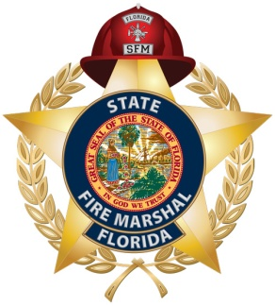

Fire Department Safety Committee
Action Plan

The purpose of this document is to provide fire department safety committees with a list of possible action items committee members can utilize in an effort to make the department a safer and healthier workplace. The list is not exhaustive nor is it mandatory, but serves only as a basis for decision making.

- Conduct, at a minimum, quarterly meetings
- Review new hire / incumbent medical physical program.
- Review “Fire Service Log and Summary of Occupational, Diseases, and Illnesses” form.
- Review Critical Incident Stress Management (CISM) policies.
- Review all accidents / incidents involving fire department apparatus.
- Review personal protective equipment (PPE) cleaning and maintenance procedures.
- Review department’s Respiratory Protection Program.
- Review Emergency Response Plan.
- Review Safety Committee policies and procedures.
- Review Exposure Control Plan
- Review department’s Risk Management Plan.
- Complete a Facilities Safety Checklist.
- Conduct an audit of the department’s compliance to Florida Administrative Code 69A-62 and Florida Statute 633.502 – 633.536 using the Florida State Fire Marshal’s “Compliance Guidance” document.

